Lecture No.39 PARASITOLOGY DR. Raad H.H.

Class Arachnida

Subclass Acarina (ticks and mites)
Characters:
- segmentation reduced so that body divided into 2 main portions in spiders and scorpion or single body mass in ticks and mites.
  - prosoma (cephalothorax)
  - opisthosoma (abdomen; essentially the area posterior to the legs)
- nymph and adults usually with 4 pair of legs
- larvae 3 pair of legs
- no antenna
- 4-stage life cycle, egg-larva-nymph-adult
- other terminology as follows
  - capitulum (gnathosoma) is an area anterior to the body and carries the feeding appendages
    - hypostome (part of the mouthparts made up of the fused coxae of the pedipalps
    - pair of pedipalps (palps; segmented second pair of arthropod appendages)
    - pair of chelicerae
  - idiosoma (entire body excluding capitulum)
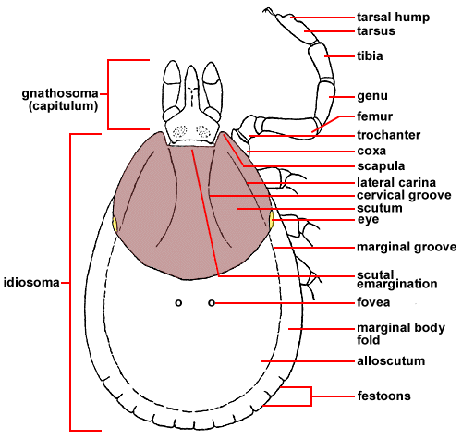
  - Haller's organ (depression on the 1st tarsus, which functions as a humidity/olfactory receptor)

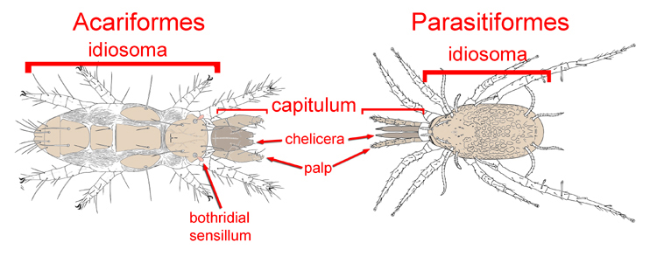

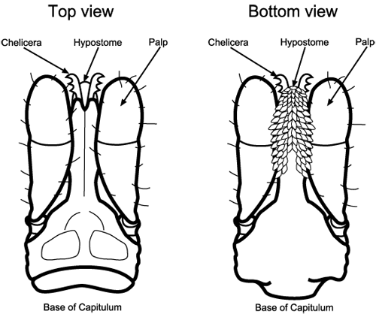

  - classification of the subclass: Acari
    - order: Ixodida (Metastigmata) (= Parasitoformes)
      - ticks; relatively large in size
      - hypostome with teeth and usually exposed anteriorly
      - Haller's organ present, on first tarsi
      - pair of spiracles near coxae of 4th pair of legs in adults
      - all parasitic
      - 2 families
        - family: Ixodidae (hard ticks)
        - family: Argasidae (soft ticks)
    - order: Mesostigmata (= Acariformes) (free-living, predaceous, and parasitic mites)
      - mites; small
      - hypostome without teeth and and hidden ventrally
      - Haller's organ absent
      - pair of spiracles between second and fourth coxae
      - both free-living and parasitic members
    - order: Prostigmata (chiggers , follicle mites Demodex sp., Trombiculid mites)
      - mites; small
      - hypostome without teeth and and hidden ventrally
      - Haller's organ absent
      - pair of spiracles sometimes present and, if present, paired and either between chelicerae or on dorsal surface near center of body
      - both free-living and parasitic members
    - order: Orbatida (Cryptostigmata) (= Acariformes)
      - mites; small
      - hypostome without teeth and and hidden ventrally
      - Haller's organ absent
      - spiracles absent
      - all free-living
    - order: Astigmata (house dust, storage & scabies mites)
      - mites; small; poorly sclerotized
      - hypostome without teeth and and hidden ventrally
      - Haller's organ absent
      - spiracles absent
      - both free-living and parasitic members

FAMILY: Ixodidae (hard ticks) (= Parasitoformes)
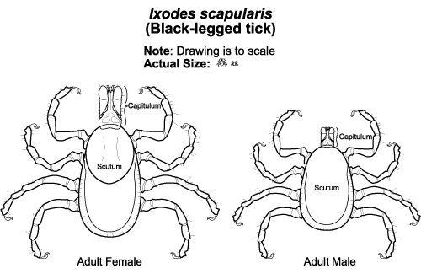
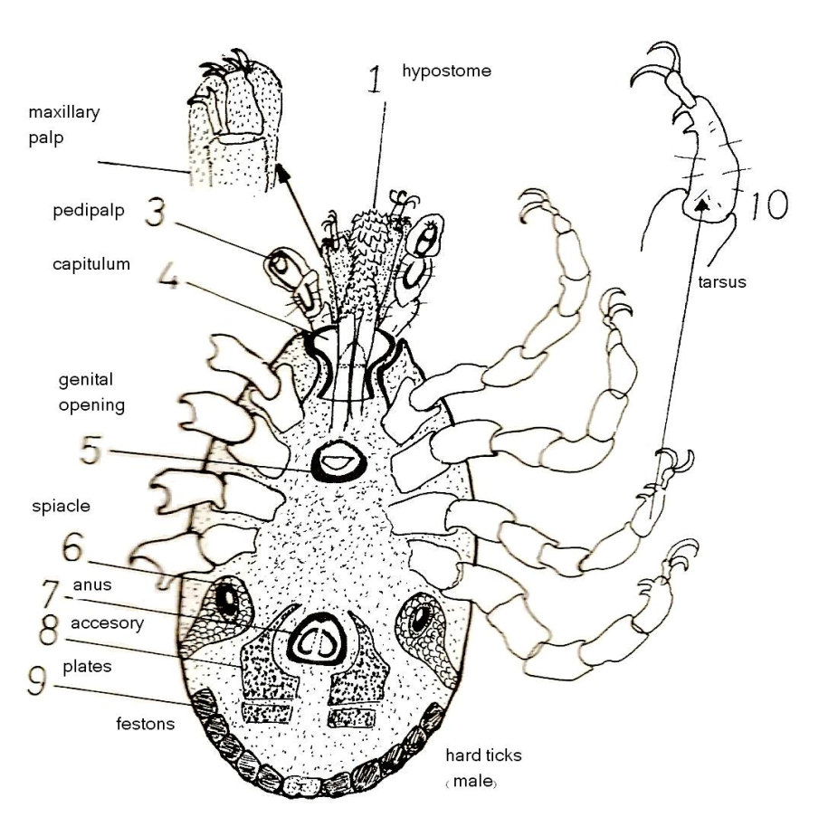

- most species are dioecious, and females usually require a blood meal prior to egg production
- copulation usually on the host
- females usually drop off the host, and lay eggs in the soil
- 6-legged larval stages hatches, and requires a blood meal to molt
- 8-legged nymph is the next stage, and requires a blood meal to molt
- nymph molts into adult
- different host seeking strategies
  - one-host ticks spend all life-cycle stages on the same host(e.g. Boophilus)
  - two-host ticks generally spend the larval and nymphal stages on one host, but the nymph drops off to molt and the adult seeks a second host(e.g. Hyalomma marginatum)
  - three-host ticks represent the majority of species, and all stages of ticks drop off the host prior to molting, and the next stages needs to seek a new host (e.g. Hyalomma anatolicum ; Ixodes)
- although some species are host specific, many are generalists
- can survive for months and sometimes for many years without taking a blood meal
- dorsal surface is covered by a sclerite termed a scutum; in adult females the scutum does not cover the entire dorsal surface so that engorging may occur
- some species possess eyes on the scutum whereas other species have no eyes
- genera
  - Ixodes spp.
      - about 40 species
      - Ixodes dentatus (rabbits)
      - Ixodes scapularis (Black-legged tick; commonly on deer in eastern and southeast Kansas; sometimes canids, humans)
      - Ixodes sculptus (burrowing mammals; skunk)
    - no festoons
    - anal groove extends anterior to the anus
    - tend to be dark ticks, with females often larger than males
    - mouthparts of females more elongate than those of the males
  - Amblyomma spp.
    - festoons present
    - anal groove extends posterior to the anus
    - secondary palp segment elongate
    - species
      - Amblyomma americanum (Lone star tick; occurs in the eastern and southern potion of the state; on many mammalian species and is the second most commonly encountered tick in eastern Kansas; female with white of pink spot at base of scutum; males smaller than females and with 2 inverted half circles at margin of scutum)
      - Amblyomma maculatum (Gulf coast tick; occurs in southern and eastern portions of the state; relatively rare; on multiple mammalian species including ruminants and cervids)
  - Dermacentor spp.
    - festoons present
    - anal groove extends posterior to the anus
    - all three palp segments short
    - species
      - Dermacentor albipictus (Winter tick; throughout Kansas; mainly on large mammals such as deer and ruminants in the Fall; dark brown to grey in color with little ornamentation)
      - Dermacentor parumapertus (Rabbit dermacentor; rabbits)
      - Dermacentor variabilis (American dog tick; throughout Kansas; on many mammalian species and the most common tick encountered in the state; varigated white ornamentation on scutum pronounced)
  - Haemaphysalis spp.
    - festoons present
    - anal groove extends posterior to the anus
    - secondary palp segment flared laterally
    - species
      - Haemaphysalis cordelius (Bird tick; probably widespread in Kansas)
      - Haemaphysalis leporispalustris (Rabbit tick; unknown distribution in Kansas)
  - Rhipicephalus sanguineus (Brown dog tick)
    - festoons present
    - anal groove extends posterior to the anus
    - basis capitulum laterally pointed, so that capitulum appears hexagonal
    - tend to be brown and ornamentation not colorful (indistinct)
    - throughout Kansas; introduced along with canids throughout the world; mainly on canids
  - Hyalomma
    - festoons present or absent
    - inornate or ornate
  - Boophilus
    - Inornate
    - festoons present
- Some sample diseases transmitted by hard ticks
  - Babesiosis (protozoan; Babesia spp.) transmitted by multiple species and genera of ticks, depending upon the protozoan species
  - East coast fever (Theileria parva) in cattle by Rhipicephalus appendicularis in Africa
  - Ehrlichiosis (bacterium; Ehrlichia spp.) transmitted by multiple species and genera of ticks, depending upon the bacterium species
  - Lyme disease (bacterium; Borrelia burgdorferi) transmitted especially by Ixodes scapularis
  - Q-fever (rickettsia); respiratory infection typically caused by Dermacentor spp.
  - Rocky mountain spotted fever (rickettsia) transmitted especially by Dermacentor andersoni; also Haemaphysalis leporispalustris between rabbits, Rhipicephalus sanguineus between canids; Amblyomma americanum
  - Texas cattle fever (Babesia bigemina) transmitted by Boophilus annulatus
  - Tick paralysis (not a pathogen); ticks ( Ixodes scapularis ; Dermacenter andersoni; Aargus ; Ornithdorus ) that bite near base of skull can sometimes induce a gradual, and reversible, paralysis due to the salivary secretions
  - Tularemia (bacterium) transmitted especially by Dermacentor andersoni (and other Dermacentor spp.)
  - Crimean-Congo hemorrhagic fever

Factors Accounting for High Vector Potential of Ticks
1. Persistent hematophagous feeders
2. Relatively slow feeding time allows time for pathogen transfer
3. Typically have a wide host range
4. Longevity increases chances of acquiring and transmitting a pathogen
5. Transovarial transmission of some pathogens
6. Few natural enemies, highly sclerotized (resistant to environmental stress)
7. High reproductive potential - up to 18,000 eggs and parthenogenesis in some species

Tick Control
- Natural predators
- Repellents/toxicants for human use
I. DEET (n, n-diethyl-m-toluamide) (apply to skin)
II. Pyrethroids (apply to clothing)
- Cultural/mechanical control
- remove shelters for hosts/ticks
- destroy wild hosts
- pasture rotation (one-host only)
- Resistant livestock breeding

- Anti-tick vaccine
- Chemical control on animal host, or acaricide in habitat
- Wear light-colored clothing to allow you to see ticks that are crawling on your clothing.
- Tuck your pants legs into your socks so that ticks cannot crawl up the inside of your pants legs.

